|  |
| --- |
| Ciconi’s Games |
| **AIRFIRE** |
| **Space War** |
| Version #1  All work Copyright © 2017 by Ciconi’s Games.  All rights reserved. |
| **Andre Lemos, Fabio Ciconi, Rodrigo Geronimo** |
|  |

|  |
| --- |
| August 04th 2017 |

**Table of Contents**

Contents

Version History 3

1. Game Overview 4

2. Game Play Mechanics 4

3. Camera 4

4. Controls 4

5. Saving and Loading 4

6. Interface Sketch 5

7. Menu and Screen Descriptions 5

8. Game World 5

9. Levels 6

10. Game Progression 6

11. Characters 6

12. Non-player Characters 6

13. Enemies 6

14. Abilities 6

15. Vehicles 7

16. Story Index 7

17. Future Features 7

# Version

Version 1.0 – Document start

# Game Overview

Are you prepared to face the best adventure of your life? You need to protect planet earth from asteroids and other enemies. Embark on the AirFire007 ship and do not let the land be destroyed.

# Game Play Mechanics

The mechanic is simple; the player needs to eliminate the asteroids and kill the wave of enemy ships. The player needs to define what is the best position to stay to defeat the enemy ships and escape the asteroids. The player can destroy the ships with fire and the asteroids they can escape or destroy.

# Camera

The game uses a 2D view, the camera does not change position.

# Controls

The game uses a simple up, down, left and right keyboard buttons and space bar to fire.

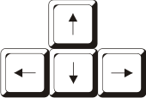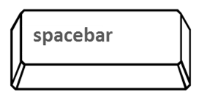

# Saving and Loading

It doesn’t have any savings or loadings.

# Interface Sketch

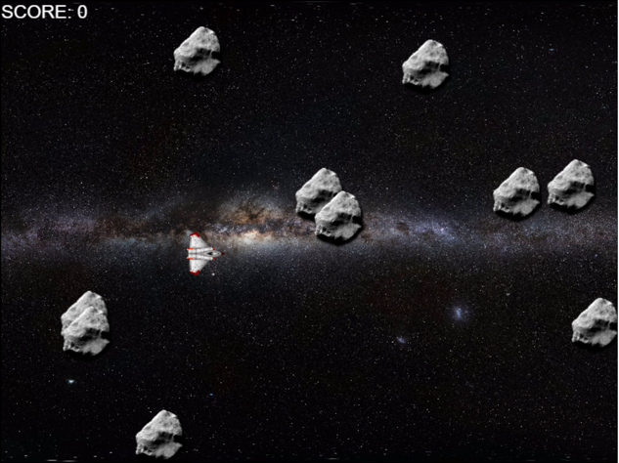

Scream shoot of the game in level 1.

# Menu and Screen Descriptions

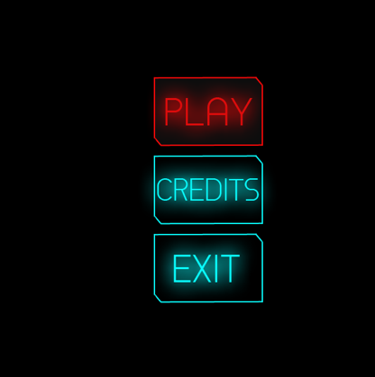

The main menu is divided in three options play, credits, and exit.

# Game World

The game happens in 2100 and the humankind remains living on earth. However, we discovered that life in universe life beyond us. Some aliens are peaceful, but other are extremely dangerous. Second, the earth lost ozone layer and we humanity face some problems with asteroids.

# Levels

The game has 3 levels.

# Game Progression

1. Easy: only asteroids.
2. Normal: asteroids and enemy’s ships.
3. Hard: Boss enemies ship.

# Characters

*(Describe Your game avatar if applicable)*

# Non-player Characters

The game doesn’t have control in the enemies and space.

# Enemies

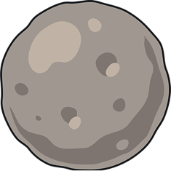Asteroid

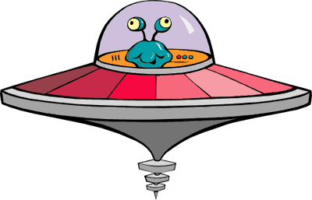Alien space ship

# Abilities

The space ship has the ability to shoot to destroy the asteroids and aliens.

C:\Users\Andre\AppData\Local\Microsoft\Windows\INetCache\Content.Word\bullet.png Sprite sheet for the space ship shoot

# Vehicles

**../AirFire/images/spaceship.png**Space ship

# Story Index

The galaxy protects recruit new pilots to protect the earth. The mission of the new pilots is to destroy the asteroids and enemies spaceships.

# Future Features

The game going to implement the alien in stage 2. Second, in stage 3 we are going to implement the mother alien spaceship that will be the final boss of the game.